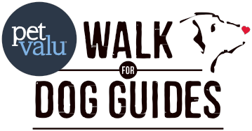National Pet Valu Walk for Dog Guides

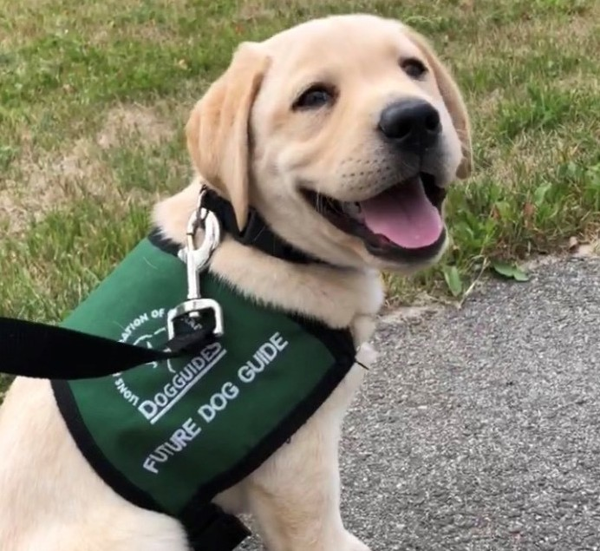Enjoy a 2.5 km or 5 km dog friendly walk
Sunday, May 31
Registration begins at [TIME], Walk begins at [TIME] [LOCATION]

Lions Foundation of Canada Dog Guides is a national charity whose mission is to empower Canadians with disabilities to navigate their world with confidence and independence by providing Dog Guides at no cost to them and supporting each pair in their journey together.

The Pet Valu Walk for Dog Guides is the largest event of its kind in Canada, now held in communities across every province. Thanks to the support of sponsors, all funds raised by participants go directly to the Dog Guide training programs.

RECOGNITION | LEVEL 1  $2,500 | LEVEL 2  $1,000 | LEVEL 3  $500 | LEVEL 4  $250
Mention in community listings for Oakville both online and print. | ✓
Opportunity to address the participants during the opening ceremonies | ✓
Mention in media advisories and releases | ✓ | ✓
Logo on promotional leaflets | ✓ | ✓
Logo on walk registration page | ✓ | ✓ | ✓
Display space at the walk | ✓ | ✓ | ✓
Verbal recognition at walk | ✓ | ✓ | ✓
Social media presence | ✓ | ✓ | ✓ | ✓
Logo in walk programs | ✓ | ✓ | ✓ | ✓
Opportunity to include an item in participant bags | ✓ | ✓ | ✓ | ✓

Silent auction and raffle prize contributions are also greatly appreciated and will be recognized on display at the walk, and through recognition on the walk website.

“I know I can trust Hero because he’s so adaptable to everything. Hero allows me to be independent and because of him, I am able to live on my own. With Hero, I feel safe to go outside my comfort zone again as I know he will keep
me safe.” – Lise-Marie, Seizure Response Graduate

CANINE VISION • HEARING • AUTISM ASSISTANCE • SERVICE • SEIZURE RESPONSE • DIABETES ALERT • FACILITY SUPPORT For more information contact Sara at (905) 842-2891 Ext 2176 or sbawar@dogguides.com
152 Wilson Street Oakville, ON L6K 0G6 www.walkfordogguides.com Charitable Tax # 13024 5129 RR0001

